**Phase5-12 Delete an S3 Bucket**

* Delete an S3 bucket

Selecting the S3 bucket you want to delete

* Choose the bucket

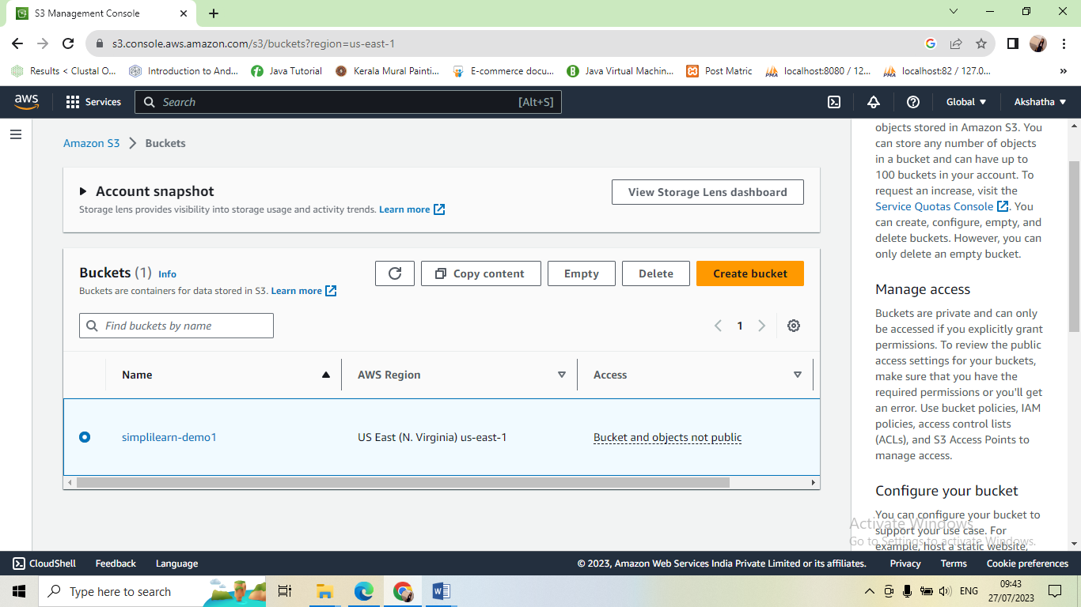

Deleting the bucket

